Hello World

helm install demo helloworldhelm --dry-run

helm install demo helloworldhelm

Hello world URL

URL: <http://aa2e0d8ef3b2743b69caa81d4dfe22c7-1913779023.us-east-1.elb.amazonaws.com/>

Prometheus:- <http://a4d8c60f360e34f629a1b5a85e62ac05-958105114.us-east-1.elb.amazonaws.com:9090/targets>

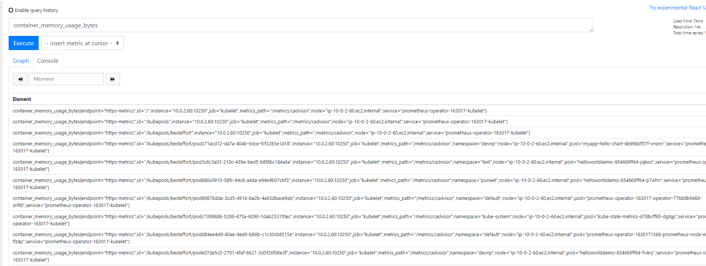

LOKI

http://a2c7ab747bffb47a49b1876553ac6e3e-1456347747.us-east-1.elb.amazonaws.com/d/JBjLPKmZz/pod-stats-and-info?orgId=**1Grafana- loki** - <http://a2c7ab747bffb47a49b1876553ac6e3e-1456347747.us-east-1.elb.amazonaws.com/explore?orgId=1&left=%5B%22now-1h%22,%22now%22,%22Loki%22,%7B%22expr%22:%22%7Bcontainer%3D%5C%22puneetdemo%5C%22%7D%22%7D,%7B%22mode%22:%22Logs%22%7D,%7B%22ui%22:%5Btrue,true,true,%22none%22%5D%7D%5Dusern>

adminame: admin

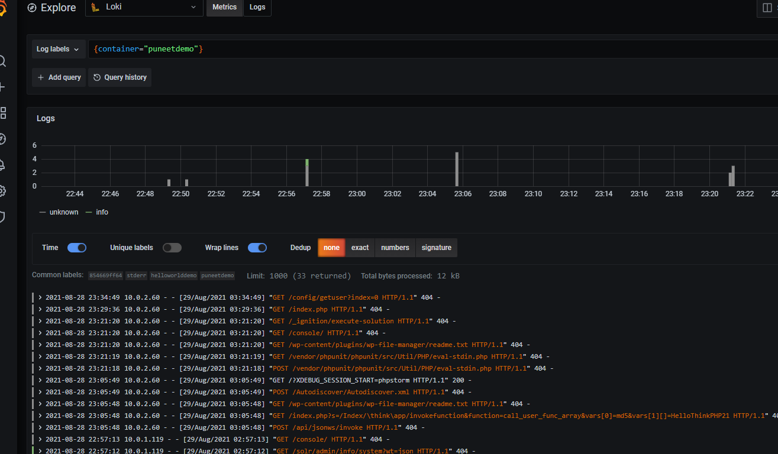

**Grafana metrics Dashboard:**

http://a2c7ab747bffb47a49b1876553ac6e3e-1456347747.us-east-1.elb.amazonaws.com/d/JBjLPKmZz/pod-stats-and-info?orgId=1Grafana-%20loki%20%20-%20%20http:%2F%2Fa2c7ab747bffb47a49b1876553ac6e3e-1456347747.us-east-1.elb.amazonaws.com%2Fexplore%3ForgId%3D1&left=%5B%22now-1h%22,%22now%22,%22Loki%22,%7B%22expr%22:%22%7Bcontainer%3D%5C%22puneetdemo%5C%22%7D%22%7D,%7B%22mode%22:%22Logs%22%7D,%7B%22ui%22:%5Btrue,true,true,%22none%22%5D%7D%5Dusername&var-namespace=puneet&var-pod=helloworlddemo-854669ff64-csjdj&var-container=All

